

**NAME:** KASHIF MAJID DAR

**DIVISION:** CS B1

**PRN:** 19070122084

**Assignment 12**

**Title:**

Structure and Union

**Objective:**  
Write a C program using structures to print the pay slip of an employee after accepting details like id. no, name, designation, department and basic salary.

**Theory:**

A structure is a user defined data type in C/C++. A structure creates a data type that can be used to group items of possibly different types into a single type.

‘struct’ keyword is used to create a structure. Following is an example.

|  |
| --- |
| struct address  {     char name[50];     char street[100];     char city[50];     char state[20];     int pin;  }; |

**Algorithm:**

1. Declare a structure of type ‘emp’ which will consist:
   * int sal, Id_No
   * char desig[40], name[40], dept[40]
2. Declare a variable p1 of type ‘emp’
3. Print: Enter the employee name
4. Scan p1.name
5. Print: Enter the employee department.
6. Scan: p1.dept
7. Print: Enter the employee salary
8. Scan: p1.sal
9. Print: Enter the employee Id_No
10. Scan: p1.Id_No
11. Print: Enter the employee designation
12. Scan: p1.desig
13. Print: The pay slip of the employee:
14. Print: "ID no. Name Designation Department Salary"
15. Print: “p1.Id_No, p1.name, p1.desig, p1.dept, p1.sal”

**FLOWCHART:**

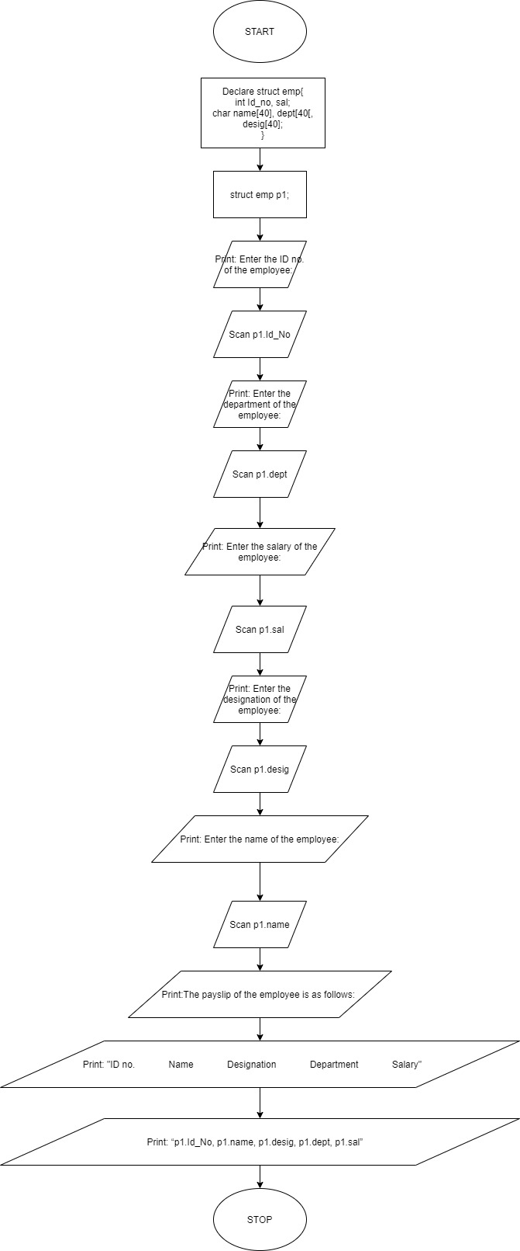

**SOURCE CODE:**

#include <stdio.h>

#include <stdlib.h>

#include <string.h>

/* run this program using the console pauser or add your own getch, system("pause") or input loop */

main()

{

struct emp

{

int Id_No, sal;

char name[40], desig[40], dept[40];

};

struct emp p1;

printf("Enter the ID no. of the employee: ");

scanf("%d", &p1.Id_No);

printf("\nEnter the salary of the employee: ");

scanf("%d", &p1.sal);

printf("\nEnter the name of the employee: ");

scanf("%s", &p1.name);

printf("\nEnter the designation of the employee: ");

scanf("%s", &p1.desig);

printf("\nEnter the department of the employee: ");

scanf("%s", &p1.dept);

printf("The details of the employee are as follows:\n\n\n\n\n");

printf("ID no. Name Designation Department Salary");

printf("\n%d %s %s %s %d", p1.Id_No, p1.name, p1.desig, p1.dept, p1.sal);

}

**OUTPUT:**

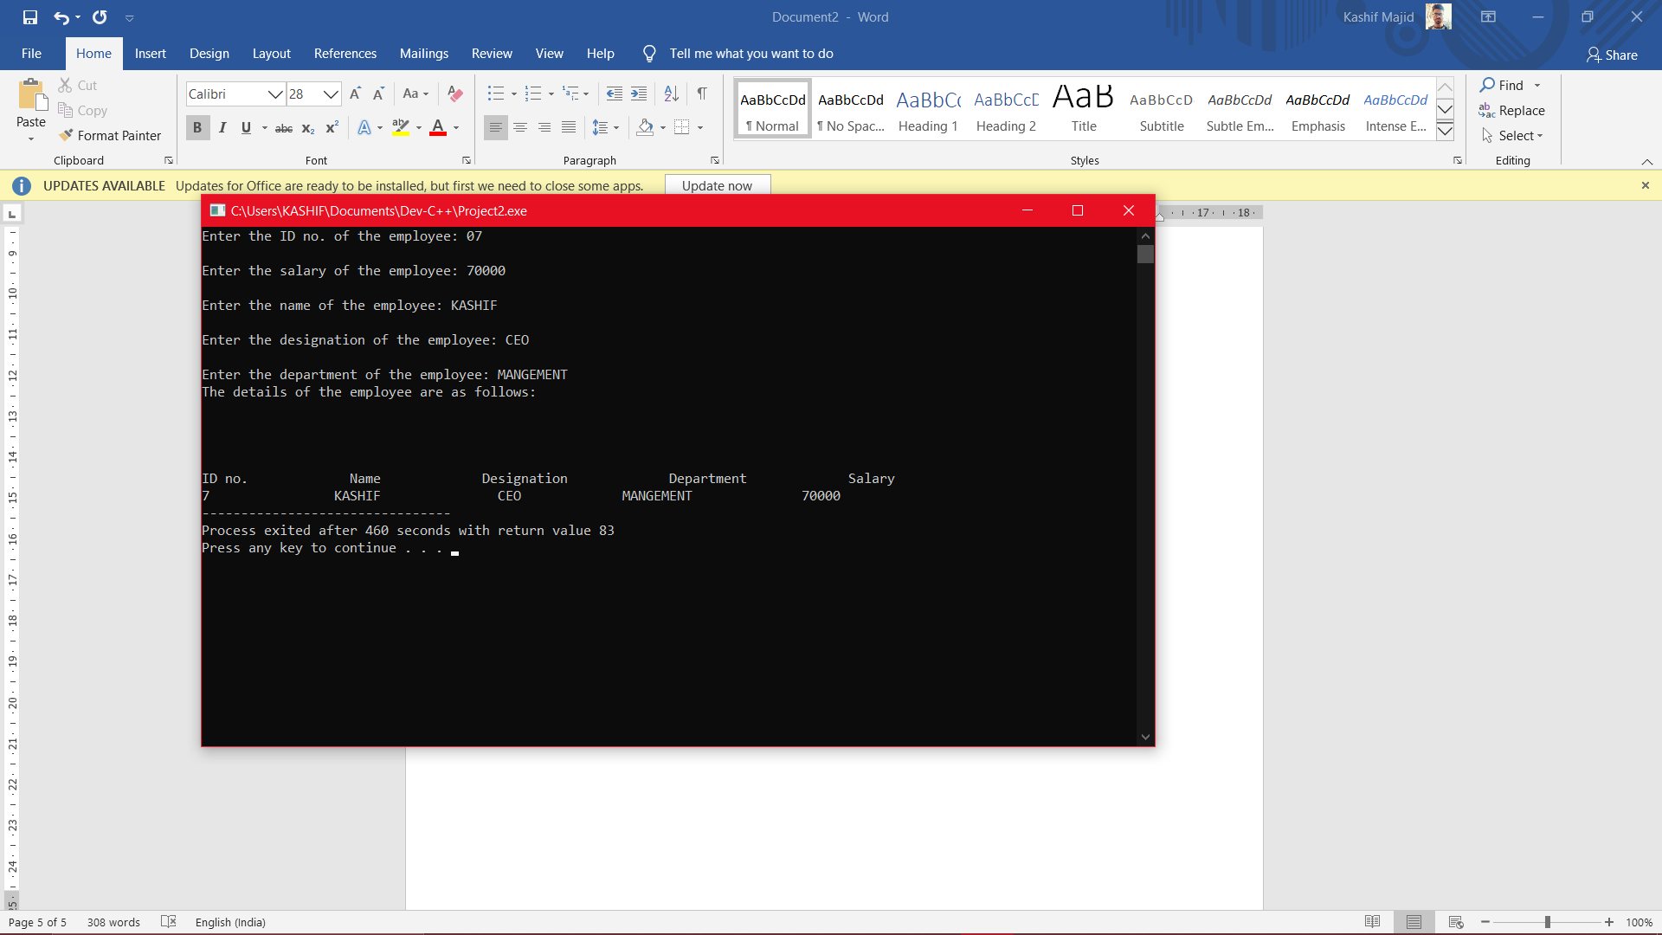

**CONCLUSION:**

With the help of structures, we can accumulate relevant data of different types about a single entity and club them together to form a convenient data type of sorts called a structure and use them multiple times according to our wish.